**Name: Mohammad Awais**

**Class: BSCS-8-A  
CMS: 242554**

# Compiler Construction Lab 8

#### < Input Grammmar >

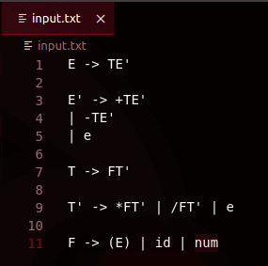

## Task 1 ( Program to Calculate Firsts )

#### < Code >

#include <iostream>

using namespace std;

#include <fstream>

#include <vector>

#include<string>

*/********************************* INITIALIZATIONS ******************************/*

vector<string> nt_list = {};

vector<string> t_list = {")","(","e","num","id","+","-","/","*"};

vector<vector<string>> nt_derivs = {};

vector<vector<string>> nt_firsts = {};

*/**********************************************************************************/*

*/* USER DEFINED FOR REPLACEMENT OF SUBTRING IN STRING */*

void replaceAll( string &s, const string &search, const string &replace ) {

for( size_t pos = 0; ; pos += replace.length() ) {

*// Locate the substring to replace*

pos = s.find( search, pos );

if( pos == string::**npos** ) break;

*// Replace by erasing and inserting*

s.erase( pos, search.length() );

s.insert( pos, replace );

}

}

*/* Find FIRST of Non-Terminal of input Index */*

vector<string> ntFirstCal(int i, char mode){

int e_case = 0;

vector<string> local_firsts = {};

if(mode=='t'){

local_firsts.push_back(t_list[i]);

}

else{

for(int j=0; j<nt_derivs[i].size();j++){

string word="";

for(int k=0; k<nt_derivs[i][j].length();k++){

char c = nt_derivs[i][j][k];

word+=c;

if(c==']'){

if(word[1]=='t'){

if(t_list[word[2]-'0']=="e"&&k!=nt_derivs[i][j].length()-1){

word="";

}

else{

int x = word[2]- '0';

local_firsts.push_back(t_list[x]);

break;

}

}

else if(word[1]=='n'){

int x = word[2]- '0';

vector<string> inherit_firsts = {};

if(nt_firsts[x].empty()){

inherit_firsts = ntFirstCal(x,'n');

}

else{

inherit_firsts = nt_firsts[x];

}

int sec_size = inherit_firsts.size();

for(int p=0; p<sec_size;p++){

string firsts = inherit_firsts[p];

if(firsts == "e" && k!=nt_derivs[i][j].length()-1){

x = nt_derivs[i][j][k+3]-'0';

c = nt_derivs[i][j][k+2];

k=k+4;

if(c=='n'){

vector<string> post_inherit_firsts = {};

if(nt_firsts[x].empty())

post_inherit_firsts = ntFirstCal(x,c);

else

post_inherit_firsts = nt_firsts[x];

for (string sfir : post_inherit_firsts){

inherit_firsts.push_back(sfir);

}

sec_size = inherit_firsts.size();

}

else{

local_firsts.push_back(t_list[x]);

}

}

else{

int exist = 0;

for(string f : local_firsts){

if(f.compare(firsts)==0){

exist = 1;

break;

}

}

if(exist==0){

local_firsts.push_back(firsts);

}

}

}

break;

}

}

}

}

nt_firsts[i] = local_firsts;

}

return local_firsts;

}

*/* Replaces Derivations with appropriate Tokens */*

void tokenizeDerivs(){

*// PRE PROCESSING*

int max_size = 0;

for(int i = 0; i<nt_list.size();i++){

int size = nt_list[i].length();

if(size>max_size){

max_size=size;

}

}

*// SUBSTITUTES DERIVATIVES WITH IDs*

for(int j = 0; j<nt_derivs.size();j++){

for(int k = 0; k<nt_derivs[j].size();k++){

string s = nt_derivs[j][k];

for(int sos=max_size; sos>0;sos--)

{for(int i=0; i<nt_list.size() ;i++){

if(sos == nt_list[i].length()){

int spos = s.find(nt_list[i]);

string x = nt_list[i];

if (spos>=0){

replaceAll(nt_derivs[j][k], nt_list[i], "[n"+to_string(i)+"]"); *// WORKING GREAT*

}}

}}

for(int i=0; i<t_list.size();i++){

int spos = s.find(t_list[i]);

if (spos>=0){

replaceAll(nt_derivs[j][k], t_list[i], "[t"+to_string(i)+"]"); *// WORKING BETTER*

}

}

}

}

}

*/* DIVIDES LHS and RHS INTO THEIR RESPECTIVE LISTS */*

void divider(string fileString){

int mode = 0;

string temp = "";

vector<string> tempList = {};

for(int i=0; i<fileString.length()-1;i++){

temp += fileString[i];

if(mode==0){

if(fileString[i+1]=='-'&&fileString[i+2]=='>'){

nt_list.push_back(temp);

i=i+2;

mode=1;

temp = "";

}

}

else if(mode==1){

if(fileString[i+1]=='\n' || fileString[i+1] == '|'){

if(fileString[i+1]=='\n'&&fileString[i+2]=='|'){

i=i+2;

}

else if(fileString[i+1]=='|'){

i=i+1;

}

else if(fileString[i+1]=='\n'&&fileString[i+2]!='|'){

mode = 0;

i=i+1;

}

tempList.push_back(temp);

temp="";

if(mode==0){

nt_derivs.push_back(tempList);

nt_firsts.push_back({}); *// For FIRST LIST*

tempList = {};

}

}

}

}

}

*/* READ FILE STRING AND STORE IN A STRING VARIABLE */*

string readNout(string filename){

string readLine;

*// Read from the text file*

ifstream grammerFile(filename);

string fileString = "";

while (getline (grammerFile, readLine)) {

*// Output the text from the file*

for(char c: readLine){

if(c!='\t' && c!=' '){

fileString=fileString+c;

}

}

if(!readLine.empty())

fileString=fileString+"\n";

}

grammerFile.close();

return fileString;

}

int main() {

cout << " \t < Program 1 >\n\n";

string filename = "input.txt";

string fileString = readNout(filename)+"\0"; *// Reads Text File Input of Grammar into String Variable*

divider(fileString); *// Divides LHS and RHS into Lists nt_list & nt_derivs*

tokenizeDerivs(); *// Tokenizes nt_derivs*

*// Calculating Firsts and storing in nt_firsts list.*

for(int i=0; i<nt_derivs.size();i++){

if(nt_firsts[i].empty()){

ntFirstCal(i,'n');

}

}

*// Displaying Firsts*

cout<<"FIRST of Non-Terminals:-\n";

for(int i=0; i<nt_firsts.size();i++){

vector<string> vec = nt_firsts[i];

cout<<"\n> First("<<nt_list[i]<<") = { ";

for(string str: vec){

cout<<str<<" , ";

}

cout<<"}\n";

}

cout << "\n\n";

return 0;

}

#### < Output >

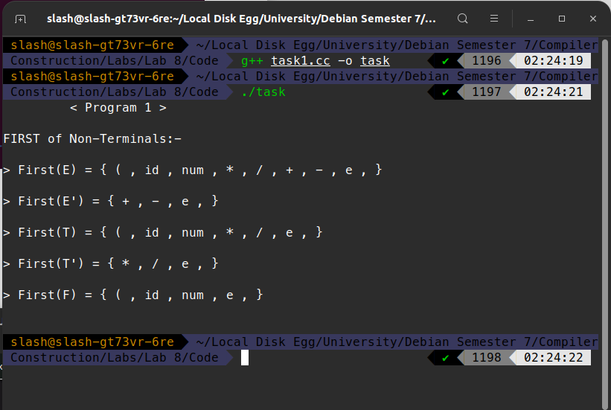

## Task 2 ( Program to Calculate Follows )

#### < Code >

#include <iostream>

using namespace std;

#include <fstream>

#include <vector>

#include<string>

*/********************************* INITIALIZATIONS ******************************/*

vector<string> nt_list = {};

vector<string> t_list = {")","(","e","num","id","+","-","/","*"};

vector<vector<string>> nt_derivs = {};

vector<vector<string>> nt_firsts = {};

vector<vector<string>> nt_follows = {};

*/**********************************************************************************/*

*/* USER DEFINED FOR REPLACEMENT OF SUBTRING IN STRING */*

void replaceAll( string &s, const string &search, const string &replace ) {

for( size_t pos = 0; ; pos += replace.length() ) {

*// Locate the substring to replace*

pos = s.find( search, pos );

if( pos == string::**npos** ) break;

*// Replace by erasing and inserting*

s.erase( pos, search.length() );

s.insert( pos, replace );

}

}

*/* Find FIRST of Non-Terminal of input Index */*

vector<string> ntFirstCal(int i, char mode){

int e_case = 0;

vector<string> local_firsts = {};

if(mode=='t'){

local_firsts.push_back(t_list[i]);

}

else{

for(int j=0; j<nt_derivs[i].size();j++){

string word="";

for(int k=0; k<nt_derivs[i][j].length();k++){

char c = nt_derivs[i][j][k];

word+=c;

if(c==']'){

if(word[1]=='t'){

if(t_list[word[2]-'0']=="e"&&k!=nt_derivs[i][j].length()-1){

word="";

}

else{

int x = word[2]- '0';

local_firsts.push_back(t_list[x]);

break;

}

}

else if(word[1]=='n'){

int x = word[2]- '0';

vector<string> inherit_firsts = {};

if(nt_firsts[x].empty()){

inherit_firsts = ntFirstCal(x,'n');

}

else{

inherit_firsts = nt_firsts[x];

}

int sec_size = inherit_firsts.size();

for(int p=0; p<sec_size;p++){

string firsts = inherit_firsts[p];

if(firsts == "e" && k!=nt_derivs[i][j].length()-1){

x = nt_derivs[i][j][k+3]-'0';

c = nt_derivs[i][j][k+2];

k=k+4;

if(c=='n'){

vector<string> post_inherit_firsts = {};

if(nt_firsts[x].empty())

post_inherit_firsts = ntFirstCal(x,c);

else

post_inherit_firsts = nt_firsts[x];

for (string sfir : post_inherit_firsts){

inherit_firsts.push_back(sfir);

}

sec_size = inherit_firsts.size();

}

else{

local_firsts.push_back(t_list[x]);

}

}

else{

int exist = 0;

for(string f : local_firsts){

if(f.compare(firsts)==0){

exist = 1;

break;

}

}

if(exist==0){

local_firsts.push_back(firsts);

}

}

}

break;

}

}

}

}

nt_firsts[i] = local_firsts;

}

return local_firsts;

}

*/* Find FOLLOW of Non-Terminal of input Index */*

vector<string> ntFollowCal(int i){

vector<string> local_follows = {};

vector<vector<int>> local_detects = {}; *// DELETE SAWA CHECK FROM HERE (UPDATE: PERHAPS NOT AS USED), MOST LIKELY ALL FOLLOWS NOT BEING CALC.*

for(int j=0; j<nt_derivs.size();j++){

if(i!=j){

for(int k=0; k<nt_derivs[j].size();k++){

for(int l=0; l<nt_derivs[j][k].length(); l++){

if(nt_derivs[j][k][l]=='n' && nt_derivs[j][k][l+1]-'0'==i){

local_detects.push_back({j,k,l+2});

}

}

}

}

}

for(vector<int> detect : local_detects){

int z = detect[0];

int a = detect[1];

int b = detect[2];

int get_out;

int x;

while(1){

get_out =1;

if(b == nt_derivs[z][a].length()-1){

vector<string> inherit_follows;

if(nt_follows[z].empty())

inherit_follows = ntFollowCal(z);

else

inherit_follows = nt_follows[z];

for(string follows: inherit_follows){

local_follows.push_back(follows);

}

}

else if(nt_derivs[z][a][b+2]=='t'){

x = nt_derivs[z][a][b+3]- '0';

if(t_list[x]=="e"){

b=b+4;

get_out = 0;

}

else{

local_follows.push_back(t_list[x]);

}

}

else if(nt_derivs[z][a][b+2] == 'n'){

x = nt_derivs[z][a][b+3] - '0';

vector<string> inherit_firsts;

if(nt_firsts[x].empty())

inherit_firsts = ntFirstCal(x,'n');

else

inherit_firsts = nt_firsts[x];

for(string first: inherit_firsts){

if(first!="e")

local_follows.push_back(first);

else{

b=b+4;

get_out = 0;

}

}

}

if(get_out==1){

break;

}

}

}

if(i==0){

local_follows.push_back("$");

}

nt_follows[i] = local_follows;

vector<string> final_local_follows = {};

for(string f : local_follows){

int detect_f = 0;

for(string t : final_local_follows){

if(f == t){

detect_f = 1;

break;

}

}

if(detect_f == 0 ){

final_local_follows.push_back(f);

}

}

nt_follows[i] = final_local_follows;

return local_follows;

}

*/* Replaces Derivations with appropriate Tokens */*

void tokenizeDerivs(){

*// PRE PROCESSING*

int max_size = 0;

for(int i = 0; i<nt_list.size();i++){

int size = nt_list[i].length();

if(size>max_size){

max_size=size;

}

}

*// SUBSTITUTES DERIVATIVES WITH IDs*

for(int j = 0; j<nt_derivs.size();j++){

for(int k = 0; k<nt_derivs[j].size();k++){

string s = nt_derivs[j][k];

for(int sos=max_size; sos>0;sos--)

{for(int i=0; i<nt_list.size() ;i++){

if(sos == nt_list[i].length()){

int spos = s.find(nt_list[i]);

string x = nt_list[i];

if (spos>=0){

replaceAll(nt_derivs[j][k], nt_list[i], "[n"+to_string(i)+"]"); *// WORKING GREAT*

}}

}}

for(int i=0; i<t_list.size();i++){

int spos = s.find(t_list[i]);

if (spos>=0){

replaceAll(nt_derivs[j][k], t_list[i], "[t"+to_string(i)+"]"); *// WORKING BETTER*

}

}

}

}

}

*/* DIVIDES LHS and RHS INTO THEIR RESPECTIVE LISTS */*

void divider(string fileString){

int mode = 0;

string temp = "";

vector<string> tempList = {};

for(int i=0; i<fileString.length()-1;i++){

temp += fileString[i];

if(mode==0){

if(fileString[i+1]=='-'&&fileString[i+2]=='>'){

nt_list.push_back(temp);

i=i+2;

mode=1;

temp = "";

}

}

else if(mode==1){

if(fileString[i+1]=='\n' || fileString[i+1] == '|'){

if(fileString[i+1]=='\n'&&fileString[i+2]=='|'){

i=i+2;

}

else if(fileString[i+1]=='|'){

i=i+1;

}

else if(fileString[i+1]=='\n'&&fileString[i+2]!='|'){

mode = 0;

i=i+1;

}

tempList.push_back(temp);

temp="";

if(mode==0){

nt_derivs.push_back(tempList);

nt_firsts.push_back({}); *// For FIRST LIST*

nt_follows.push_back({}); *// For FOLLOWS LIST*

tempList = {};

}

}

}

}

}

*/* READ FILE STRING AND STORE IN A STRING VARIABLE */*

string readNout(string filename){

string readLine;

*// Read from the text file*

ifstream grammerFile(filename);

string fileString = "";

while (getline (grammerFile, readLine)) {

*// Output the text from the file*

for(char c: readLine){

if(c!='\t' && c!=' '){

fileString=fileString+c;

}

}

if(!readLine.empty())

fileString=fileString+"\n";

}

grammerFile.close();

return fileString;

}

int main() {

cout << " \t < Program 2 >\n\n";

string filename = "input.txt";

string fileString = readNout(filename)+"\0"; *// Reads Text File Input of Grammar into String Variable*

divider(fileString); *// Divides LHS and RHS into Lists nt_list & nt_derivs*

tokenizeDerivs(); *// Tokenizes nt_derivs*

*// Calculating Firsts and storing in nt_firsts list.*

for(int i=0; i<nt_derivs.size();i++){

if(nt_firsts[i].empty()){

ntFirstCal(i,'n');

}

}

*// Displaying Firsts*

cout<<"FIRST of Non-Terminals:-\n";

for(int i=0; i<nt_firsts.size();i++){

vector<string> vec = nt_firsts[i];

cout<<"\n> First("<<nt_list[i]<<") = { ";

for(string str: vec){

cout<<str<<" , ";

}

cout<<"}\n";

}

*// Calculating Follows and storing in nt_follows list.*

for(int i=0; i<nt_derivs.size();i++){

if(nt_follows[i].empty()){

ntFollowCal(i);

}

}

*// Displaying Follows*

cout<<"\n\nFOLLOWS of Non-Terminals:-\n";

for(int i=0; i<nt_follows.size();i++){

vector<string> vec = nt_follows[i];

cout<<"\n> Follow("<<nt_list[i]<<") = { ";

for(string str: vec){

cout<<str<<" , ";

}

cout<<"}\n";

}

cout << "\n\n";

return 0;

}

#### < Output >

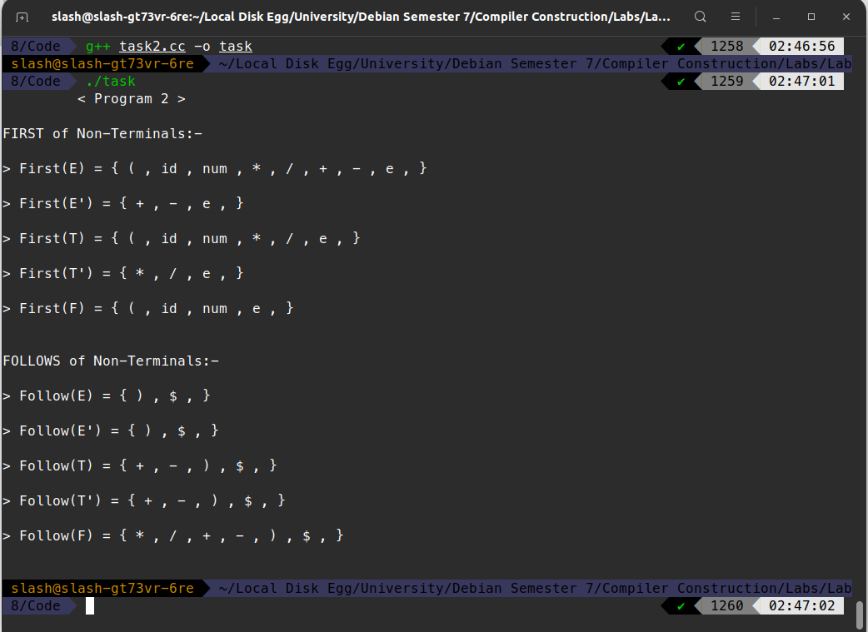

## Task 3 ( Parsing Table )

#### < Code >

#include <iostream>

using namespace std;

#include <fstream>

#include <vector>

#include<string>

*/********************************* INITIALIZATIONS ******************************/*

vector<string> nt_list = {};

vector<string> t_list = {")","(","e","num","id","+","-","/","*"};

vector<vector<string>> nt_derivs = {};

vector<vector<string>> nt_derivs_o = {};

vector<vector<string>> nt_firsts = {};

vector<vector<string>> nt_parsing_entries = {};

vector<vector<string>> nt_follows = {};

vector<vector<string>> parsingTable = {};

*/**********************************************************************************/*

*/* USER DEFINED FOR REPLACEMENT OF SUBTRING IN STRING */*

void replaceAll( string &s, const string &search, const string &replace ) {

for( size_t pos = 0; ; pos += replace.length() ) {

*// Locate the substring to replace*

pos = s.find( search, pos );

if( pos == string::**npos** ) break;

*// Replace by erasing and inserting*

s.erase( pos, search.length() );

s.insert( pos, replace );

}

}

*/* Find FIRST of Non-Terminal of input Index */*

vector<string> ntFirstCal(int i, char mode){

int e_case = 0;

vector<string> local_firsts = {};

vector<string> local_pentries = {};

if(mode=='t'){

local_firsts.push_back(t_list[i]);

}

else{

for(int j=0; j<nt_derivs[i].size();j++){

string word="";

for(int k=0; k<nt_derivs[i][j].length();k++){

char c = nt_derivs[i][j][k];

word+=c;

if(c==']'){

if(word[1]=='t'){

if(t_list[word[2]-'0']=="e"&&k!=nt_derivs[i][j].length()-1){

word="";

}

else{

int x = word[2]- '0';

local_firsts.push_back(t_list[x]);

local_pentries.push_back(nt_list[i]+"->"+nt_derivs_o[i][j]);

break;

}

}

else if(word[1]=='n'){

int x = word[2]- '0';

vector<string> inherit_firsts = {};

if(nt_firsts[x].empty()){

inherit_firsts = ntFirstCal(x,'n');

}

else{

inherit_firsts = nt_firsts[x];

}

int sec_size = inherit_firsts.size();

for(int p=0; p<sec_size;p++){

string firsts = inherit_firsts[p];

if(firsts == "e" && k!=nt_derivs[i][j].length()-1){

x = nt_derivs[i][j][k+3]-'0';

c = nt_derivs[i][j][k+2];

k=k+4;

if(c=='n'){

vector<string> post_inherit_firsts = {};

if(nt_firsts[x].empty())

post_inherit_firsts = ntFirstCal(x,c);

else

post_inherit_firsts = nt_firsts[x];

for (string sfir : post_inherit_firsts){

inherit_firsts.push_back(sfir);

}

sec_size = inherit_firsts.size();

}

else{

local_firsts.push_back(t_list[x]);

local_pentries.push_back(nt_list[i]+"->"+nt_derivs_o[i][j]);

}

}

else{

int exist = 0;

for(string f : local_firsts){

if(f.compare(firsts)==0){

exist = 1;

break;

}

}

if(*/*exist==0*/*1){

local_firsts.push_back(firsts);

local_pentries.push_back( nt_list[i]+"->"+nt_derivs_o[i][j]);

}

}

}

break;

}

}

}

}

nt_firsts[i] = local_firsts;

nt_parsing_entries[i] = local_pentries;

}

return local_firsts;

}

*/* Find FOLLOW of Non-Terminal of input Index */*

vector<string> ntFollowCal(int i){

vector<string> local_follows = {};

vector<vector<int>> local_detects = {}; *// DELETE SAWA CHECK FROM HERE (UPDATE: PERHAPS NOT AS USED), MOST LIKELY ALL FOLLOWS NOT BEING CALC.*

for(int j=0; j<nt_derivs.size();j++){

if(i!=j){

for(int k=0; k<nt_derivs[j].size();k++){

for(int l=0; l<nt_derivs[j][k].length(); l++){

if(nt_derivs[j][k][l]=='n' && nt_derivs[j][k][l+1]-'0'==i){

local_detects.push_back({j,k,l+2});

}

}

}

}

}

for(vector<int> detect : local_detects){

int z = detect[0];

int a = detect[1];

int b = detect[2];

int get_out;

int x;

while(1){

get_out =1;

if(b == nt_derivs[z][a].length()-1){

vector<string> inherit_follows;

if(nt_follows[z].empty())

inherit_follows = ntFollowCal(z);

else

inherit_follows = nt_follows[z];

for(string follows: inherit_follows){

local_follows.push_back(follows);

}

}

else if(nt_derivs[z][a][b+2]=='t'){

x = nt_derivs[z][a][b+3]- '0';

if(t_list[x]=="e"){

b=b+4;

get_out = 0;

}

else{

local_follows.push_back(t_list[x]);

}

}

else if(nt_derivs[z][a][b+2] == 'n'){

x = nt_derivs[z][a][b+3] - '0';

vector<string> inherit_firsts;

if(nt_firsts[x].empty())

inherit_firsts = ntFirstCal(x,'n');

else

inherit_firsts = nt_firsts[x];

for(string first: inherit_firsts){

if(first!="e")

local_follows.push_back(first);

else{

b=b+4;

get_out = 0;

}

}

}

if(get_out==1){

break;

}

}

}

if(i==0){

local_follows.push_back("$");

}

nt_follows[i] = local_follows;

vector<string> final_local_follows = {};

for(string f : local_follows){

int detect_f = 0;

for(string t : final_local_follows){

if(f == t){

detect_f = 1;

break;

}

}

if(detect_f == 0 ){

final_local_follows.push_back(f);

}

}

nt_follows[i] = final_local_follows;

return local_follows;

}

*/* Replaces Derivations with appropriate Tokens */*

void tokenizeDerivs(){

*// PRE PROCESSING*

int max_size = 0;

for(int i = 0; i<nt_list.size();i++){

int size = nt_list[i].length();

if(size>max_size){

max_size=size;

}

}

nt_derivs_o = nt_derivs;

*// SUBSTITUTES DERIVATIVES WITH IDs*

for(int j = 0; j<nt_derivs.size();j++){

for(int k = 0; k<nt_derivs[j].size();k++){

string s = nt_derivs[j][k];

for(int sos=max_size; sos>0;sos--)

{for(int i=0; i<nt_list.size() ;i++){

if(sos == nt_list[i].length()){

int spos = s.find(nt_list[i]);

string x = nt_list[i];

if (spos>=0){

replaceAll(nt_derivs[j][k], nt_list[i], "[n"+to_string(i)+"]"); *// WORKING GREAT*

}}

}}

for(int i=0; i<t_list.size();i++){

int spos = s.find(t_list[i]);

if (spos>=0){

replaceAll(nt_derivs[j][k], t_list[i], "[t"+to_string(i)+"]"); *// WORKING BETTER*

}

}

}

}

}

*/* DIVIDES LHS and RHS INTO THEIR RESPECTIVE LISTS */*

void divider(string fileString){

int mode = 0;

string temp = "";

vector<string> tempList = {};

for(int i=0; i<fileString.length()-1;i++){

temp += fileString[i];

if(mode==0){

if(fileString[i+1]=='-'&&fileString[i+2]=='>'){

nt_list.push_back(temp);

i=i+2;

mode=1;

temp = "";

}

}

else if(mode==1){

if(fileString[i+1]=='\n' || fileString[i+1] == '|'){

if(fileString[i+1]=='\n'&&fileString[i+2]=='|'){

i=i+2;

}

else if(fileString[i+1]=='|'){

i=i+1;

}

else if(fileString[i+1]=='\n'&&fileString[i+2]!='|'){

mode = 0;

i=i+1;

}

tempList.push_back(temp);

temp="";

if(mode==0){

nt_derivs.push_back(tempList);

nt_firsts.push_back({}); *// For FIRST LIST*

nt_follows.push_back({}); *// For FOLLOWS LIST*

nt_parsing_entries.push_back({});

tempList = {};

}

}

}

}

}

*/* READ FILE STRING AND STORE IN A STRING VARIABLE */*

string readNout(string filename){

string readLine;

*// Read from the text file*

ifstream grammerFile(filename);

string fileString = "";

while (getline (grammerFile, readLine)) {

*// Output the text from the file*

for(char c: readLine){

if(c!='\t' && c!=' '){

fileString=fileString+c;

}

}

if(!readLine.empty())

fileString=fileString+"\n";

}

grammerFile.close();

return fileString;

}

int main() {

cout << " \t < Program 3 >\n\n";

string filename = "input.txt";

string fileString = readNout(filename)+"\0"; *// Reads Text File Input of Grammar into String Variable*

divider(fileString); *// Divides LHS and RHS into Lists nt_list & nt_derivs*

tokenizeDerivs(); *// Tokenizes nt_derivs*

*// Calculating Firsts and storing in nt_firsts list.*

for(int i=0; i<nt_derivs.size();i++){

if(nt_firsts[i].empty()){

ntFirstCal(i,'n');

}

}

*// Displaying Firsts*

cout<<"FIRST of Non-Terminals:-\n";

for(int i=0; i<nt_firsts.size();i++){

vector<string> vec = nt_firsts[i];

cout<<"\n> First("<<nt_list[i]<<") = { ";

for(string str: vec){

cout<<str<<" , ";

}

cout<<"}\n";

}

*// Calculating Follows and storing in nt_follows list.*

for(int i=0; i<nt_derivs.size();i++){

if(nt_follows[i].empty()){

ntFollowCal(i);

}

}

*// Displaying Follows*

cout<<"\n\nFOLLOWS of Non-Terminals:-\n";

for(int i=0; i<nt_follows.size();i++){

vector<string> vec = nt_follows[i];

cout<<"\n> Follow("<<nt_list[i]<<") = { ";

for(string str: vec){

cout<<str<<" , ";

}

cout<<"}\n";

}

*// Calculating Parsing Table*

t_list.push_back("$");

for(int i=0; i<nt_list.size();i++){

vector<string> column_data = {};

for(int j=0; j<t_list.size();j++){

*//if(t_list[j]!="e") // Note this one in final version*

column_data.push_back("");

}

parsingTable.push_back(column_data);

}

for(int i=0; i<nt_list.size();i++){

int mode = 0;

for(int j=0; j<t_list.size();j++){

*//if(t_list[j]!='e') // Note this one in final version*

for(int x =0;x<nt_firsts[i].size();x++){

if(nt_firsts[i][x]!="e"){

if(nt_firsts[i][x]==t_list[j]){

parsingTable[i][j]+=nt_parsing_entries[i][x] + ", ";

}

}

else{

mode = 1;

}

}

}

if(mode==1){

for(int j=0; j<t_list.size();j++){

for(int x =0;x<nt_follows[i].size();x++){

if(nt_follows[i][x]==t_list[j]){

parsingTable[i][j]+=nt_list[i]+"->e"+", ";

}

}

}

}

}

*// Displaying Parsing Table*

cout<<"\n\nParsing Table:-\n\n";

for(int i=0; i<t_list.size(); i++){

if(t_list[i]!="e")

cout<<"\t\t"<<t_list[i];

}

cout<<"\n\n\n";

for(int i=0; i<nt_list.size();i++){

cout<<nt_list[i];

for(int j=0;j<t_list.size();j++){

*//if(t_list[j]!='e') // Note this one in final version*

if(t_list[j]!="e"){

if(parsingTable[i][j].empty()){

cout<<"\t{\t}";

}

else

cout<<"\t{ "<<parsingTable[i][j]<<" }";

}

}

cout<<"\n\n";

}

cout << "\n\n";

return 0;

}

#### < Output >

